Homework 5

# Abstract

This homework discusses the construction and results of an extended Kalman filter designed to estimate the trajectory of a spacecraft using range, range rate, and bearing measurements. These measurements were all taken by the Goldstone California deep space network station. There are two main steps in a Kalman filter these are propagation and update. The propagation step estimates the state at some future time based on the best guess of the state at the current time.

# Initial conditions and set up

The state of the spacecraft is represented by $\vec{x}$. All measurements of the state are in the ECI frame unless otherwise stated. The state represents both the position ($\vec{r})$ and velocity ( $\vec{v})$ of the spacecraft which can be seen in equation 1.

$$\begin{aligned}\vec{x}= \left[\begin{matrix}\vec{r} \\ \vec{v}\end{matrix}\right]\#\left[1\right]\end{aligned}$$

The dynamics used in this Kalman filter are nonlinear of the form in equation 2. In equation 2 $w$ is white noise that is applied to the acceleration. This is the process noise in the system.

$$\begin{aligned}\dot{\vec{x}}=f\left(\vec{x},t\right)+Gw\#\left[2\right]\end{aligned}$$

In the assignment $G$ and $Q$ are defined as below in equation 4 and 5 respectively. In equation 5 $σ_{w}$ is 0.05.

$$\begin{aligned}G= \left[\begin{matrix}0_{3x3} \\ I_{3x3}\end{matrix}\right]\#\left[4\right]\end{aligned}$$

$$\begin{aligned}Q=σ_{w}^{2}*I_{3x3}\#\left[5\right]\end{aligned}$$

The initial state given was that of ${\vec{x}}_{0}$ and the initial covariance matrix is $P_{0}$. Each of these can be seen in equations 6 and 7 respectively. The first three entries in the state are the x, y, and z position of the spacecraft. The following three entries are the spacecraft’s velocity in each of those directions.

$$\begin{aligned}{\vec{x}}_{0}^{T}=\left[500, 6500,3500,-10,2,3\right]\#\left[6\right]\end{aligned}$$

$$\begin{aligned}P_{0}={\left[\begin{matrix}100 & 0 & 0 & 0 & 0 & 0 \\ 0 & 100 & 0 & 0 & 0 & 0 \\ 0 & 0 & 100 & 0 & 0 & 0 \\ 0 & 0 & 0 & 0.1 & 0 & 0 \\ 0 & 0 & 0 & 0 & 0.1 & 0 \\ 0 & 0 & 0 & 0 & 0 & 0.1\end{matrix}\right]}^{2}\#\left[7\right]\end{aligned}$$

# Propagate step

The propagate step of the Kalman filter takes the state and covariance matrix from one time creates the state and covariance matrix for some other future time. In equation 2 $f$ finds the derivative of the state given the current state and time. The construction of the function $f$ can be seen in equation 8. In this equation $μ$ is the gravitational parameter of earth in $km^{3}/s^{2}$.

$$\begin{aligned}f\left(\vec{x},t\right)=\left[\begin{matrix}\vec{v} \\ \frac{-μ*\vec{r}}{{\left\|\vec{r}\right\|}^{3}}\end{matrix}\right]\#\left[8\right]\end{aligned}$$

The derivative of $f$ with respect to the state can then be computed to get $F$ which when multiplied by the state will result in the time derivative of the state. The formulation of $F$ can be seen in equation 9. The formulation of $A$ then follows in equation 10.

$$\begin{aligned}F= \left[\begin{matrix}0_{3x3} & I_{3x3} \\ A_{3x3} & 0_{3x3}\end{matrix}\right]\#\left[9\right]\end{aligned}$$

$$\begin{aligned}A= \frac{3*μ*\vec{r}*{\vec{r}}^{T}}{{\left\|\vec{r}\right\|}^{5}}-\frac{μ*I_{3x3}}{{\left\|\vec{r}\right\|}^{3}}\#\left[10\right]\end{aligned}$$

The rate of change of the covariance matrix can be computer with equation 11.

$$\begin{aligned}\dot{P}=F*P+P*F^{T}+G*Q*G^{T}\#\left[11\right]\end{aligned}$$

The new covariance matrix, $P_{2}$, at $t_{2}$ can be found with equation 12. Where $P_{1}$ and $t_{1}$ are the current covariance matrix and time.

$$\begin{aligned}P_{2}=P_{1}+\dot{P}*\left(t_{2}-t_{1}\right)\#\left[12\right]\end{aligned}$$

The state at time $t_{2}$ can then be found with equation 13.

$$\begin{aligned}{\vec{x}}_{2}={\vec{x}}_{1}+\dot{\vec{x}}*\left(t_{2}-t_{1}\right)\#\left[13\right]\end{aligned}$$

# Range update

There are several key steps in using a range measurement to update the state of the spacecraft. First is how the range is calculated, this can be seen in equation 14.

$$\begin{aligned}ρ=\left\|\vec{r}-\vec{R}\right\|\#\left[14\right]\end{aligned}$$

In equation 14 $\vec{R}$ is the location of the Goldstone station in the ECI frame and $ρ$ is the range measurement. This can then be used to compute the measurement sensitivity matrix, $H$. This is done by finding the derivative of range with respect to the position vector and the velocity vector. The resulting measurement sensitivity matrix can be seen in equation 15.

$$\begin{aligned}H_{ρ}=\left[\begin{matrix}{〈\vec{r}-\vec{R}〉}^{T} & 0_{1x3}\end{matrix}\right]\#[15]\end{aligned}$$

The next step is to calculate the $R_{k}$ for use in the Kalman gain equation. Because range is a scalar measurement this is simply the square of the uncertainty in the measurement. The uncertainty in these range measurements is 10 km. This can then be used to compute the Kalman gain which is shown in equation 16.

$$\begin{aligned}K=P*H^{T}*{\left(H*P*H^{T}+R_{k}\right)}^{-1}\#[16]\end{aligned}$$

With this it is then possible to update the state and covariance matrix. This is shown in equations 17 and 18 respectively. A superscript $–$ indicates that is the value before the update and a superscript $+$ indicates that is the value after the update. In equation 17 $y_{ρ}$ is the new range measurement being used to update the state.

$$\begin{aligned}{\vec{x}}^{+}={\vec{x}}^{-}+K\left(y_{ρ}-\left\|{\vec{r}}^{-}-\vec{R}\right\|\right)\#\left[17\right]\end{aligned}$$

$$\begin{aligned}P^{+}=\left(I-K*H\right)*P^{-}*{\left(I-K*H\right)}^{T}+K*R*K^{T}\#\left[18\right]\end{aligned}$$

Each $H$, $P$, $R_{k}$, and $K$ are unique to each measurement and time, so need to be recalculated at each update step.

# Bearing update

The formulation of the bearing measurement, $b$, is as follows.

$$\begin{aligned}b= \frac{\vec{r}-\vec{R}}{\left\|\vec{r}-\vec{R}\right\|}\#\left[19\right]\end{aligned}$$

Similar steps to the range update are followed to find the measurement sensitivity matrix. The derivative of the bearing measurement with respect to the position vector can be seen in equation 20.

$$\begin{aligned}\frac{∂b}{∂\vec{r}}=\frac{I_{3x3}}{\left\|\vec{r}-\vec{R}\right\|}-\frac{\left(\vec{r}-\vec{R}\right)*{\left(\vec{r}-\vec{R}\right)}^{T}}{{\left\|\vec{r}-\vec{R}\right\|}^{3}}\#\left[20\right]\end{aligned}$$

The resulting bearing measurement sensitivity matrix can be seen in equation 21.

$$\begin{aligned}H=\left[\begin{matrix}{\frac{∂b}{∂\vec{r}}}_{3x3} & 0_{3x3}\end{matrix}\right]\#\left[21\right]\end{aligned}$$

The uncertainty in these bearing measurements, $σ_{b}$, is 1 arc minute. The $R_{k}$ matrix for the bearing measurements is formulated using the QUEST model and is shown in equation 22.

$$\begin{aligned}R_{k}=σ_{b}^{2}*\left(I_{3x3}-b*b^{T}\right)\#\left[22\right]\end{aligned}$$

The steps to then calculate the Kalman gain and new covariance matrix are the same as the range update. The equation required to update the state is in equation 23. In that equation $y_{b}$ is the new bearing measurement being used to update the state.

$$\begin{aligned}{\vec{x}}^{+}={\vec{x}}^{-}+K\left(y_{b}- \frac{{\vec{r}}^{-}-\vec{R}}{\left\|{\vec{r}}^{-}-\vec{R}\right\|}\right)\#\left[23\right]\end{aligned}$$

# Range rate update

The final measurement type used here is range rate which is represented by $\dot{ρ}$. The formulation of range rate can be seen below in equation 24. The rotation rate of the ECEF frame relative to the ECI frame is represented by $ω_{E}^{I}$.

$$\begin{aligned}\dot{ρ}=b^{T}*\left(\vec{v}-ω_{E}^{I}×R\right)\#\left[24\right]\end{aligned}$$

The process for finding the measurement sensitivity matrix is the same as the previous two update steps. The steps used to find the measurement sensitivity matrix can be seen in equations 25, 26, and 27.

$$\begin{aligned}\frac{∂\dot{ρ}}{∂\vec{r}}={\left(\frac{∂b}{∂\vec{r}}\right)}^{T}*\left(\vec{v}-ω_{E}^{I}×R\right)\#\left[25\right]\end{aligned}$$

$$\begin{aligned}\frac{∂\dot{ρ}}{∂\vec{v}}=b^{T}\#\left[26\right]\end{aligned}$$

$$\begin{aligned}H_{\dot{ρ}}=\left[\begin{matrix}\frac{∂\dot{ρ}}{∂\vec{r}} & b^{T}\end{matrix}\right]\#\left[27\right]\end{aligned}$$

The steps to then calculate the Kalman gain and new covariance matrix are the same as the other two measurement updates. The equation required to update the state is in equation 28. In that equation $y_{\dot{ρ}}$ is the new range rate measurement being used to update the state.

$$\begin{aligned}{\vec{x}}^{+}={\vec{x}}^{-}+K\left(y_{\dot{ρ}}- b^{T}*\left(\vec{v}-ω_{E}^{I}×R\right)\right)\#\left[28\right]\end{aligned}$$

# Results

With the equations necessary to do each of the update steps and the propagate step it is possible to create the extended Kalman filter. This filter starts with the initial state and propagates to the next available measurement then updates its state and covariance matrix with the given measurement. The state and covariance matrix are then propagated to the next measurement and this repeats for all of the available measurements. The results can be compared in a few different ways with the true trajectory given with the homework. The true trajectory and results of the EKF filter plotted in 3D can be seen in Figure 1.

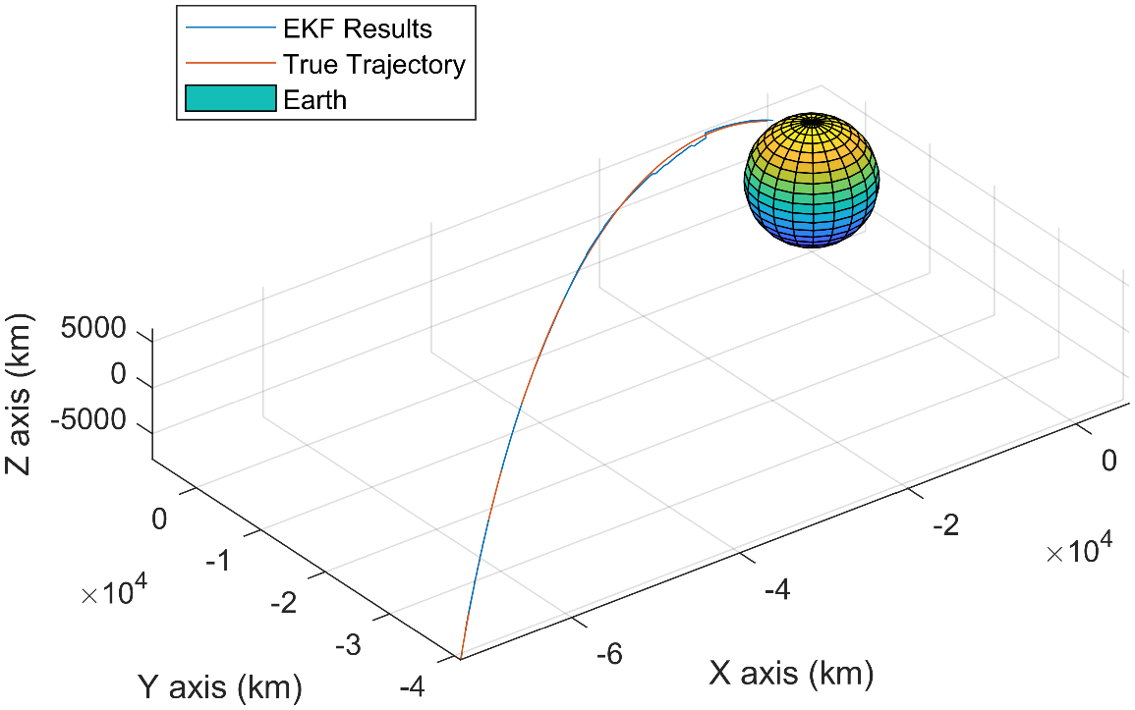

Figure 1: 3D plot of true trajectory and Kalman filter result

The following plots show the x, y, and z positions with three sigma from the Kalman filter along with the true trajectory.

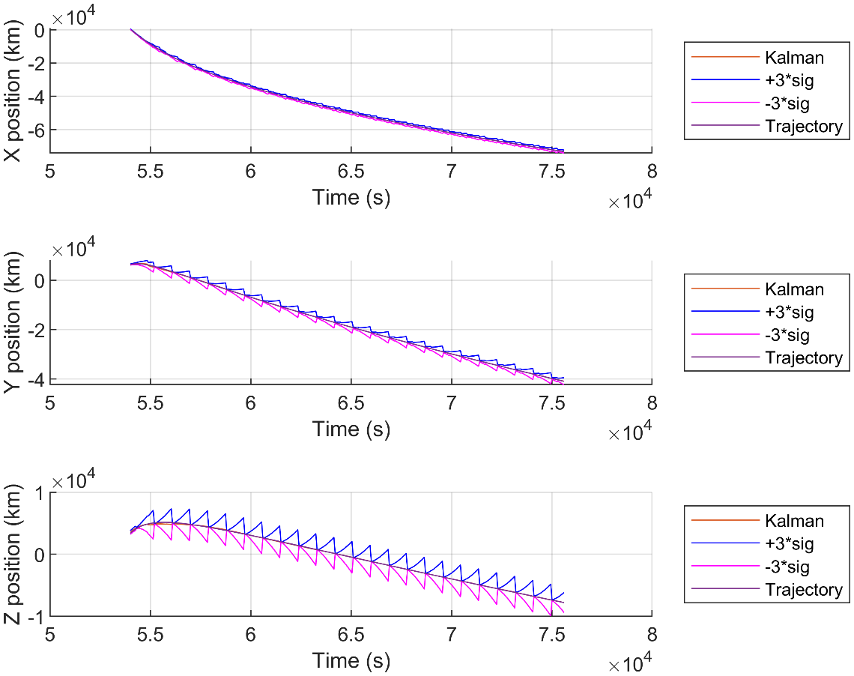

Figure 2: X, Y, Z position and sigma

The same style of plot can be done for the X, Y, and Z components of velocity.

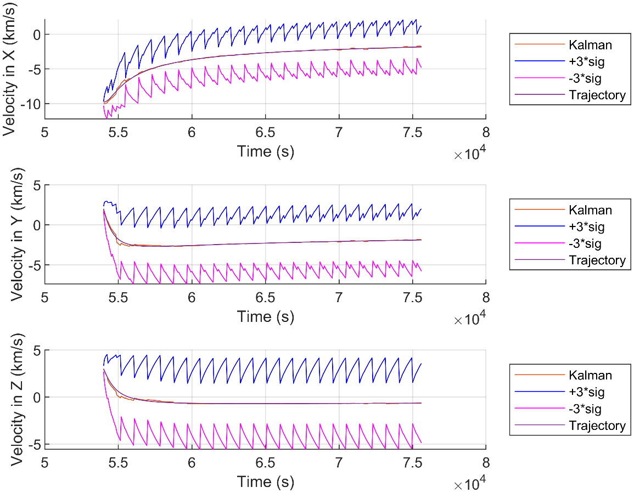

Figure 3: X, Y, and Z components of velocity and three sigma

The error between the result of the Kalman filter and the true trajectory can also be plotted for all of the components of the state. In the error of the X and Y position you can kind of see how the error rebounds which is interesting. This could be because of the measurements being different from what is expected. This reminds me though of an under damped system which is interesting because the calculated Kalman gain should be the optimal gain.

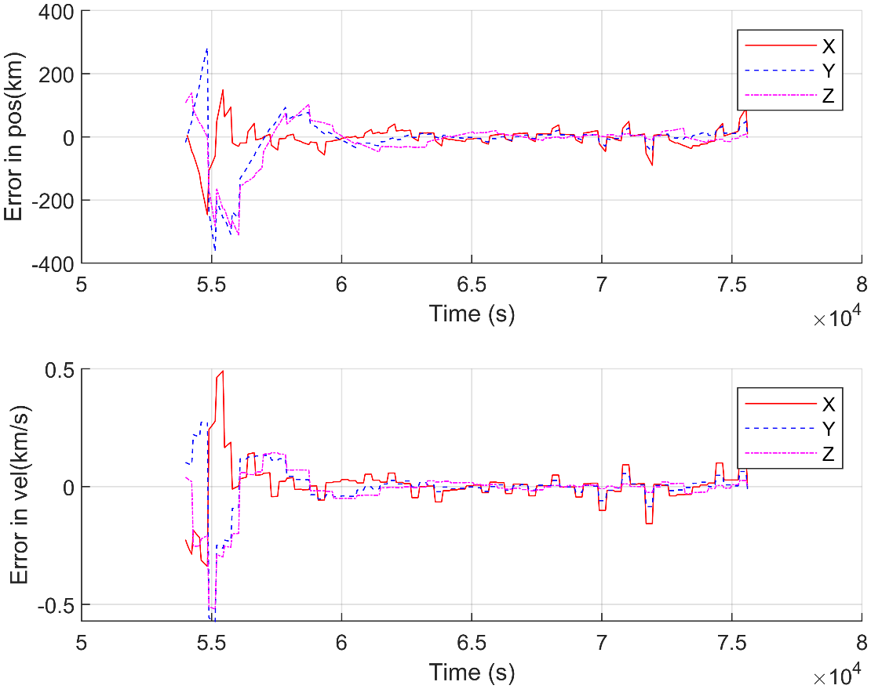

Figure 4: Error in state

The three sigma uncertainty of each measurement can be plotted over the error in the state and can be seen in Figure 5. The magnitude of the three sigma for each of the position measurements is far greater than the error of the each of the components. In the velocity error plot it is possible that the error sneaks outside of the three sigma range near the start, but is hard to tell.

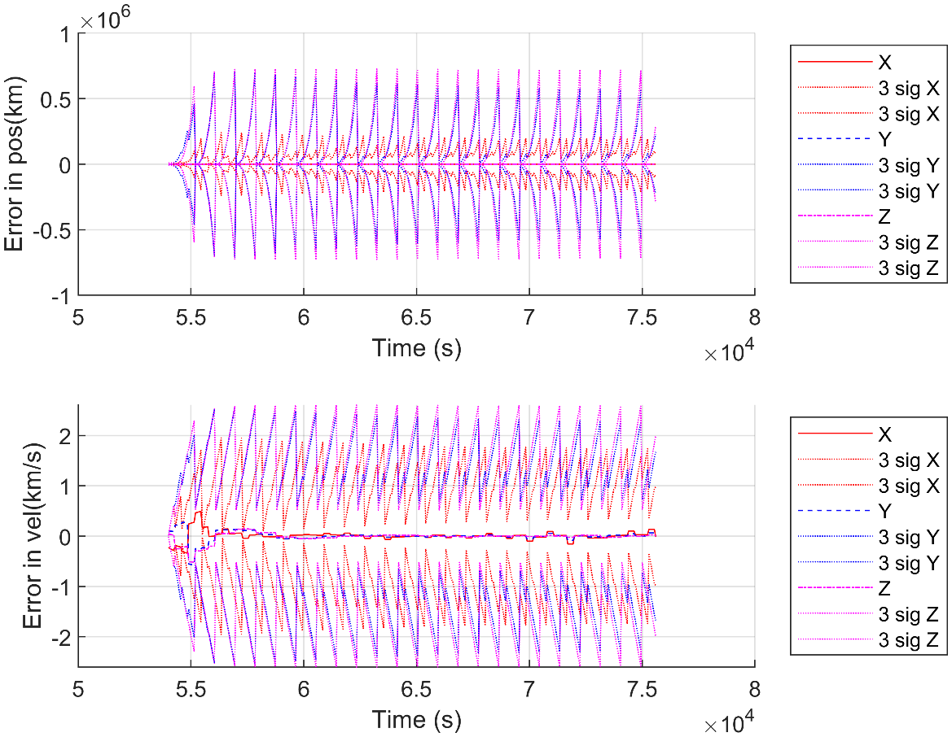

Figure 5: Error of state with three sigma plotted

Overall this extended Kalman filter does a very good job of matching the true trajectory with the given measurements.